  By Agnieszka Siwek & Agnieszka Krygier

2007-04-25

Dear diary,

Sorry that I haven’t written for such a long time but there wasn’t an interesting topic to write about. Today I got up at 7 o’clock ☹
I was sleepy but I had to go to school… I went to the bathroom quickly, washed my face, teeth etc and I got dressed
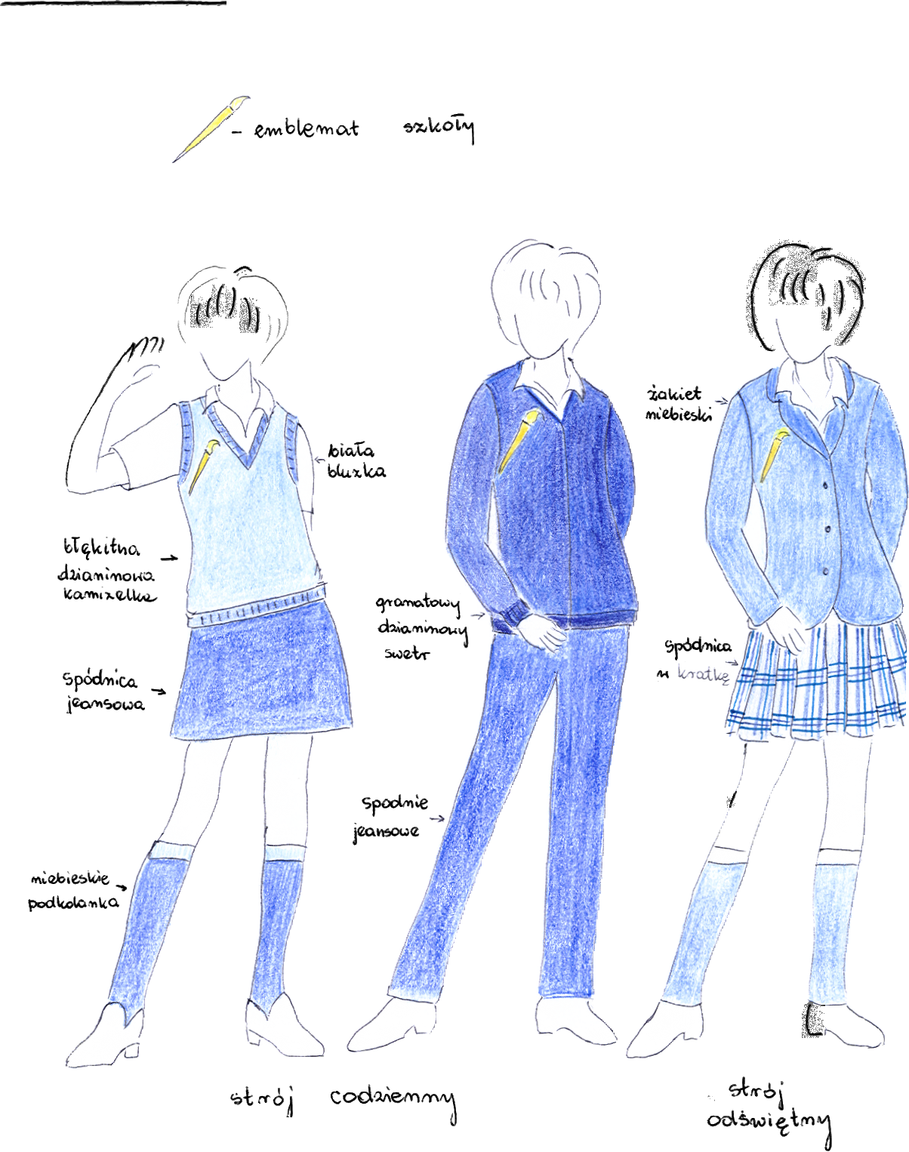
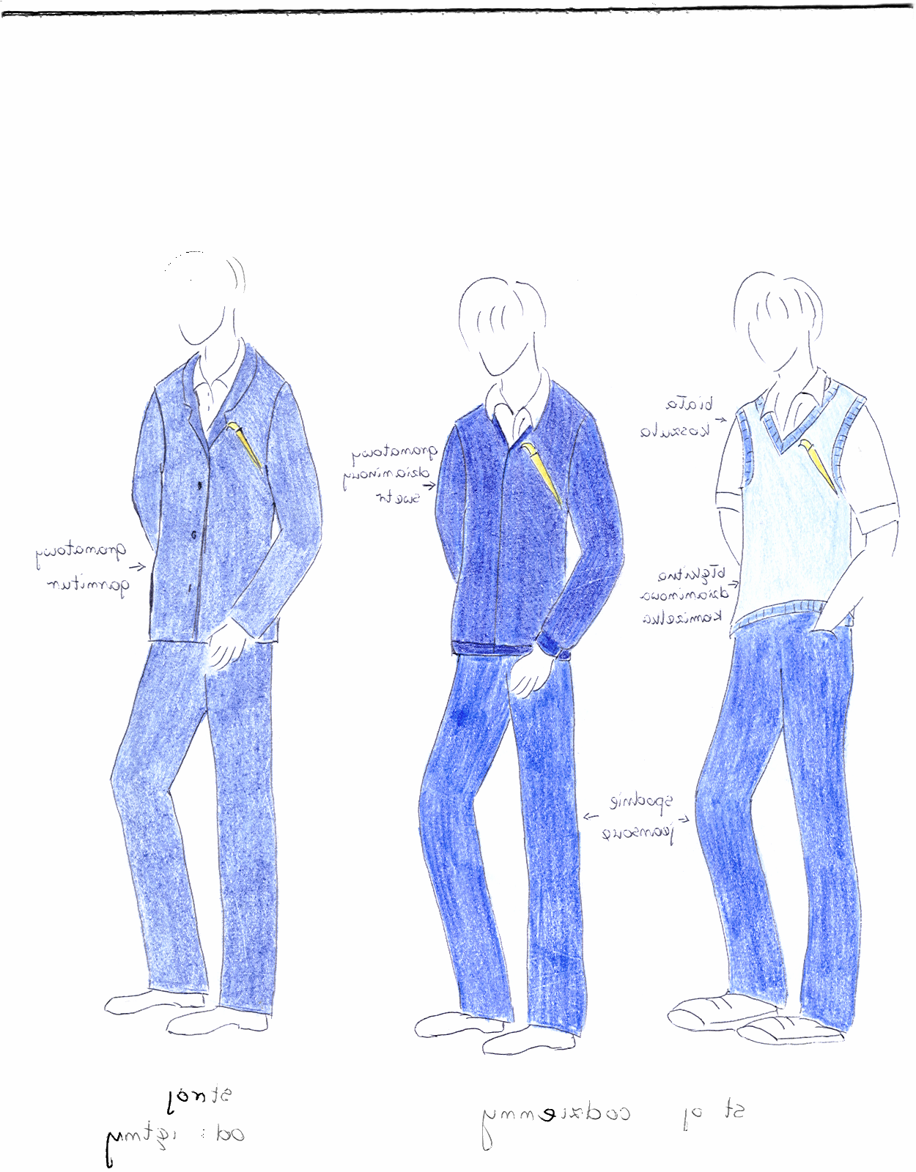
We don’t have to wear school uniform at school, you can wear what you want but bright colours are not allowed. (Bye the way: the things will change in September, according to a new law, all junior secondary school students will have to wear school uniforms. In our school there was a competition, everyone could take part in it and design an outfit for school. This is one of the projects. Isn’t it smart?)

But we have to wear special indentity cards with a photo.



I went to the kitchen. For breakfast I just had some yoghurt ☺ I was in a hurry I usually have something more like a cheese sandwich or scrambled eggs with a slice of bread and tomato salad. I often drink a cup of tea or a glass of fruit juice.
I grabbed my packed lunch ( prepared by my mum)
and I ran to the bus stop. The bus arrived on time.

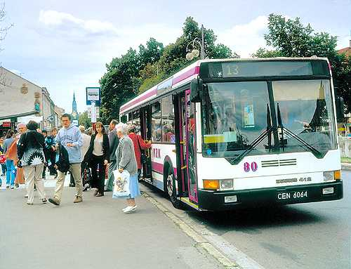

I was at school at 7:50

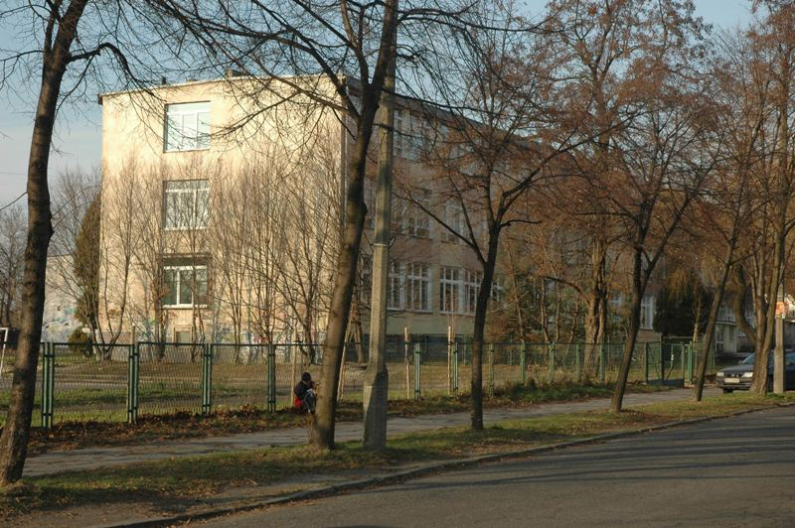

We usually have 6 hours of lessons every day.
Lessons start at 8 o’clock and you mustn’t be
late.

 | Monday | Tuesday | Wednesday | Thursday | Friday
1. | Physics | Polish | English | Biology | RS
2. | Polish | Polish | Chemistry | Polish | PE
3. | Math | Math | Physics | PE | Art
4. | History | Geography | Polish | English | Geography
5. | PE | English | History | Math | Chemistry
6. |  | IT | Math | Social Education | Politics
7. |  |  | RS

I had some time to talk to my friends before lessons.
My classmates were very nervous because the first lesson was Math and we had a twenty-minute test.
(I think the teachers love giving us tests!)
We have special school rules: students’ rights are, for example,: teachers can’t give us bad marks on Friday 13, we can only write two big tests in a week time;
students’ obligations: we have to change shoes at school, there are always students on duty in each class responsible for the order in the classroom, and many others. The rules are in a document called Statut.
Students have their student self-government which publishes our school newspaper called Cela 12. (cela in Polish means cell, 12 is the number of our secondary school) You can find the latest school news there, students’ own works, jokes and interesting photos.
The long breaks are for snacks, we often eat sandwiches (prepared at home) and drink some juice or buy something in a kiosk (usually crisps, a doughnut, a bar of chocolate and other unhealthy (but delicious!) food.
Today I had a piece of brown bread with butter, a leaf of green salad and cottage cheese and some orange juice.

Fortunately my friend had a birthday and she brought some sweets to the class (it’s a tradition).



The last lesson was computer studies. Good for us we had to find some information in the Internet which is always interesting for me.

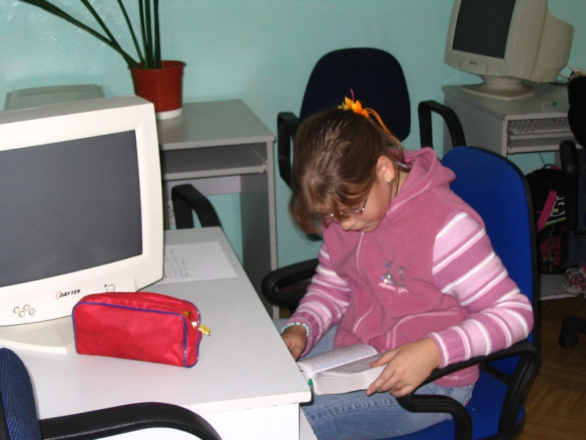

After 6 exhausting hours at school I could come back home.
For dinner I had my favourite chicken with potatoes and salad ☺ We usually have dinner at home as there’s no canteen at school. It used to be a canteen two years ago but there weren’t many students to have their meal there.
After dinner I watched my favourite soap opera,(it’s about Polish family and it’s called “Zlotopolscy” I don’t usually spend too much time watching television but some of my friends are telly addicts. They like watching soaps, reality shows, games and other popular programmes.
Most of my peers spend their afternoons having different activities.

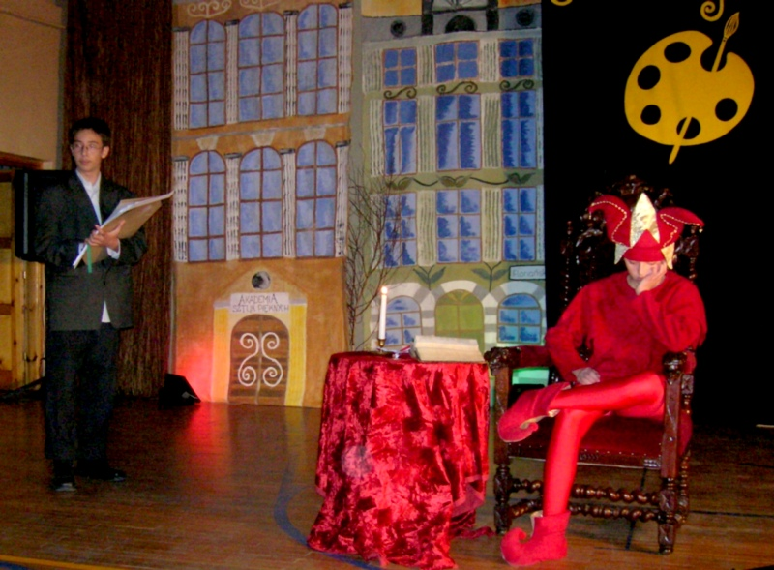

They have rehearsals in a Drama club.

They play sports in the school ground or gym.

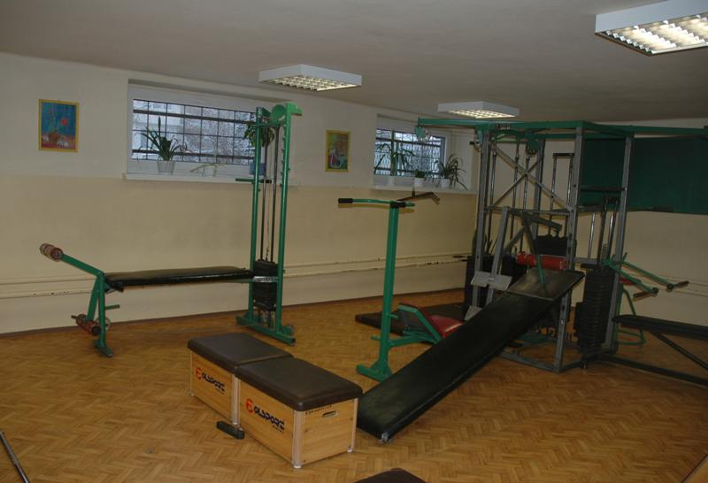

They can meet in many clubs or sing in our school group Bravissimo.

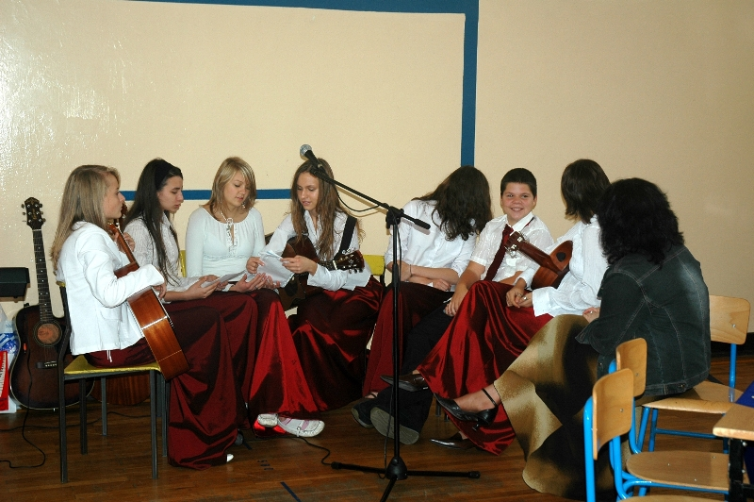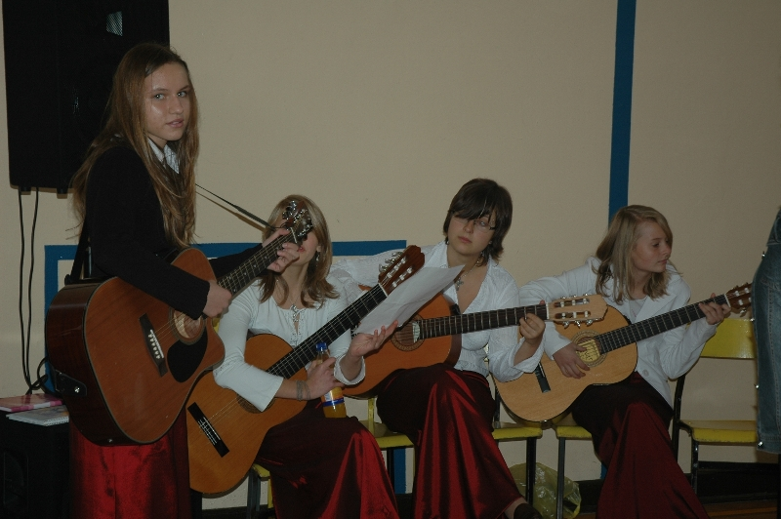

We also meet after school and go somewhere to have fun.

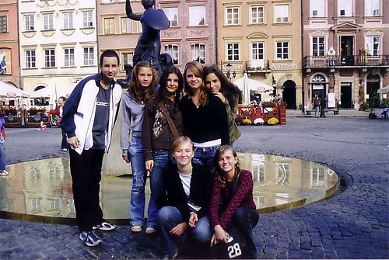

I had my extra English lesson at 4 p.m.
I went back home at 6:00 and I had to do my homework ☹ The teachers give us homework every day. We have to write essays in Polish, do the calculations or study for other subjects. Everyone wants to get good marks 6 or 5, nobody wants to get 2or 1( these are the worst grades because we have the scale from 6 to 1).
Today it wasn’t so bad , I could manage to do my homework it in one hour and a half.
At 7:30 I ate supper: sandwiches with cheese and tomatoes. Then I chatted online with friends. We often “meet” at that time to talk about what happened during the day.
Now it’s 9:30 and I’m feeling a little bit sleepy so I’m going to have a shower and go to bed.
Goodnight! ☺

