A one day diary

This is Tuesday the 17th April.
My name is Dennis Malmodin and I’m 12 years old. I got up 7 am and I was happy. For breakfast I had sandwich and hot chocolate. I wore black jeans and a yellow t-shirt. I biked to the school. When I was in school we had maths and science on the morning. Before lunch I had English .For lunch we had fish and potato. After school I played a computer game, world of warcraft. And I did some homework before dinner. I got meatballs and potato. I was going to bed at 21:00.

Tuesday 17th April 2007 ☺

My name is Lenita Paronen and I am from Sweden. I am a girl and 12 years old. It is Tuesday 17th April 2007.This is my day:

The day started at 6.40 am and I got up from my bed. I went to the kitchen and made some breakfast, porridge and strawberry tea. Then I went to the bathroom and washed my hair.
Yesterday I already unpacked my clothes so I put them on:

♦Black socks
♦Brief
♦T-shirt
♦Sweatshirt
♦Jeans

After that I went to brush my teeth. Then I was ready for school. I went down to the basement and picked up my bike and biked to school. I met my friends outside the school and then we went in to lesson.
♦Lesson 1: Math, I worked with percent.
♦Lesson 2: Science, I worked with a little house.
♦Lesson 3: Health, we walked.
♦Lesson 4: English, I worked with this project.
♦Lesson 5: Swedish, I read a book.

For lunch we got fish and potatoes. Between meals I ate two sandwiches and a glass of milk.
For dinner I got chicken and spaghetti.

When I got home from school, I did my homework. Then I watched “7th heaven” on TV and after that I watched “the Simpson”.

Then I was fooling around with my best friend William. We have so much fun together. ☺

I went to bed at 9.30 pm. This was my day. Hope it was fun to read it. ☺

Good bye!

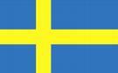

Tuesday 17th April 2007

My name is Sandra. I’m a 13 years old girl who likes to ride. Today is Tuesday 17th April.

I got up at 7.15 am after my mum has woken me up. Then I put on beige trousers and a white and turquoise t-shirt. I had cereals and sandwiches for breakfast. It was a sunny day, so I biked to school. When school started at 8.20 am, we had maths, natural science, health and English before lunch. For lunch we had fish and potatoes. After we had eaten we had Swedish and social science. When school ended at 2.50 pm I biked home. I had no homework to do so on the afternoon I just read and sat by the computer. When the clock was ca 5.00-6.00 I and my family ate dinner, chicken nuggets and macaronis. At 8.00 I watched Bones on TV. After Bones, at 9.00 pm I went to bed.

Goodbye!

Me and my pony… ☺
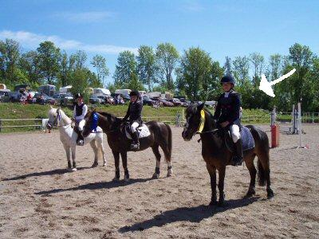
My Tuesday 17th April 2007
My name is Sandra Bermell, I’m a 12 year old girl and I live in Sweden.

This is my Tuesday 17th April 2007:
I woke up at 7.20am and I put on a grey t-shirt and a pair of jeans. Then I went downstairs to eat my breakfast sour milk and a sandwich with milk. Then I brushed my teeth. After that I went to my friend Linn’s house because we go to school together. Our first lesson starts 8.20am that was maths. We are working with per cent. Then we had science. 10.20pm. We are making a little house. After that we had health. We took a long walk. Then we had English. We are writing this diary. Then we ate lunch, fish in basil and tomatoes with potatoes. After the lunch we had two Swedish lessons. We are reading a book and then we write about it. Our last lesson was Social since. We are doing a crime play. School ended at 2.50pm. Then I went home and ate a saanwich. At 5.30pm I ate Dinner mashed potatoes and sausages with vegetables. After the Dinner my friend Linn came because we are going to the scouts together. When I came home I watched Desperate Housewives. Then I went to bed at 10.20pm.

A one day diary☺
My name is Julia Marklund, and I’m a 13 year old girl☺. Today it is Tuesday 17th April. I got up 07:05 am and went to bed 10:15 pm. To breakfast I eat two sandwiches whit cheese and butter. Today I wear blue jeans and a blue H2O sweater. The school started 08:20 am and
ended 02:50 pm☺. I walk to school whit my friend Emelie☺.Our schema looks like this: when we come to school we have maths in that we working whit per cent, after maths we have Science and there we build a little house, after that we have Health and there we go for a walk☺, after that we have English and there I wrote this diary after that we have lunch .Today in school we eat fish and potatoes, but the fish was in a gravy and I don’t like it so mush, so I eat sandwiches to lunch today☺. After lunch we have two Swedish lessens and in that we are reading a book. After that we have Social Science in that we working whit a trail play.
And when I come home I eat sandwiches. Then I bounce on my trampoline ☺ it was fun and after that I have footballs training and it was funnier☺.To dinner I eat hamburger. And before I go to bed I watched Höök on the Tv. This day I don’t have any homework ☺.

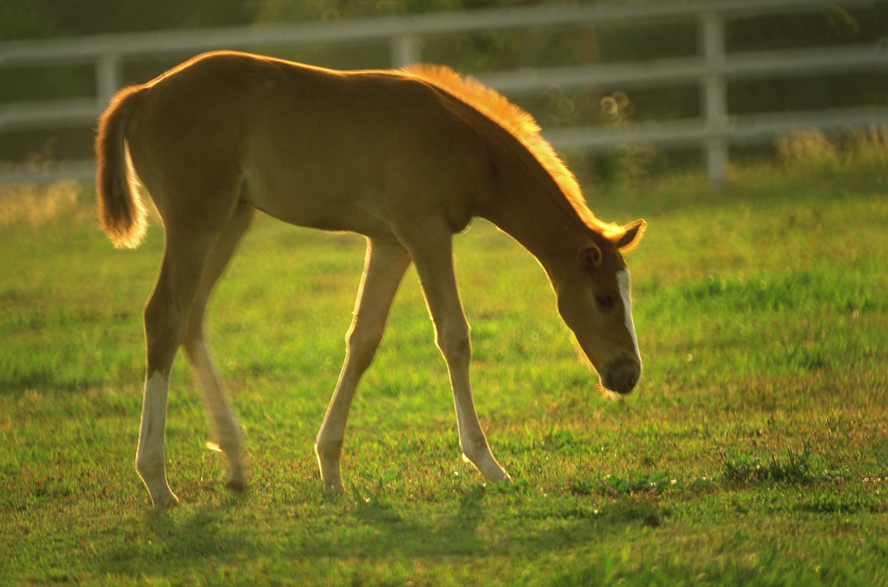
Tuesday 17th April

My name is Frida Johansson and I am a girl who loves to ride. I am
Twelve years old, but I been
Thirteen on Friday 20th April. Today is it Tuesday 17th April. I woke up at 7.00 am
and I eat some Sandwich and drink a cup of tea. After the Breakfast I went to my room
and dressed up. I had a red and white T-shirt and black jeans and a grey sweater
with black spots on it. When I was done I biked to school at 8.00 am. The first lesson
Is maths and we working with per cent after that we had science and we are doing a
little house. We had health and on the lesson we walk. After the health we had English
and we are Writing this Dairy and after the lesson we have lunch, to lunch we eat fish and potatoes . Then we had Swedish and on that lesson we are reading a book, after that I had social science. After school I Walk home to my friend I We Played games and looking on horse pictures. When a get home on the Evening I eat pasta, meatballs and tomatoes gravy .I watched TV and the program on the TV it was Ugly Betty and Desperate housewives .I went to bed at 10pm.Good Bye ☺!

This is me
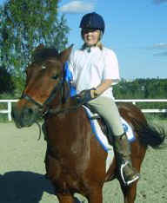

This is me when I compete I came on second place
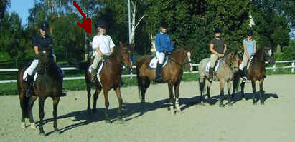

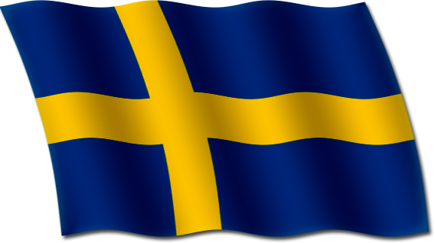
My name is Benjamin Pettersson and I am 12 years old. Today it is Tuesday 17th April.
a one day diary
When a got up the clock was 8,50am. To breakfast a eat sandwich, juice and yoghurt.
Today a took the bike. School started 8, 20 am. Today a have jeans on me and a withe t-shirt and a cardigan. The first lesson was math then we hade science and after that we hade health,
Health is fun. After health we had English. After English we had lunch. Today we had fish and potatoes with tomatoes/basil gravy. After the lunch we had Swedish then social science.
After social science the school ended. I biked home. When I come home I take some bread.
Then I wasted TV. After that I do my home work, math. After my homework I play computer. The game I played was the online game Travian. It’s very fun! To dinner I eat a kind of smoked sausage and potatoes. After dinner I played whit my rats. My rats name is past and cholera. Then I go and slepp. The clock was 10:00 tm

Made by: Benjamin Pettersson!

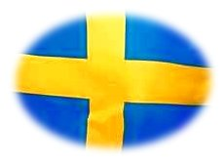
A one day diary

My name is Johannes and I am 13 years old and I am a boy.
Today it is Tuesday 17th April. I got up at 7:00 then I ate breakfast at 7:10. I ate sandwich and yoghurt and then I biked to school. In school I wear soft pants and a t-shirt. At school we had maths and we are working with percent. And after maths we had science and we build a small house. Then we had health and we took a walk. After that we had English and worked with this text☺.Then we had Swedish, we read a book and then we had social science, we do a trial play. And our teacher gave us one homework in English about Easter. For lunch we ate fish and potatoes. And after school I played handball and watched Prison Break. I ate bread and sausages and after prison break I went to bed 11:00 pm
A day of my day

This is Thursday 17th April. My name is Pontus Nygaards an I am 12 years old. I got up at 7
am and I was very tired. for breakfast I had a sandwich and hot chotlade. My cloths are black pants and a red shirt. I wallc school. School started at 8.20 am. My first lesson was math. After maths we had science and then health. After that we had the last lesson before lunch and we had English. For lunch we had fish and potatoes. After lunch we had Swedish. Then we had a Swedish lesson again. After the Swedish lessons we had the last lesson for too day. It was social science. When school end 3am I went football plan played football until 4 am. When I was home I did my English homework until 6 pm. 6 pm I had taco. When I was done I played TV games. I played Fifa 07 until 8pm. 8pm I watching on Ugly Betty. When I have watched Ugly Betty I to bed.

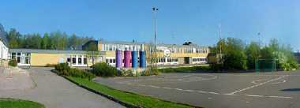


Tuesday17th April

My name is Daniel Paulsson and I am 12 years old. Today it is Tuesday17th April. I got up at 6:30 and then I had breakfast, I had yoghurt, tea and sandwich. I biked to school at 8:00 and school started at 8:20. First we had maths and we worked with percent. After maths and we had science we build a small house. Then we had health and we walked. Then we had English and we wrote a diary. After that, at 11:50, we had lunch and we had fish and potato. After lunch we had Swedish and we wrote about a book. Then we had social science. We do a trial play. School ended at 14:50.When I came home I drank a glass of yoghurt. Then I went outside and jumped on my big trampoline. For dinner we had spaghetti and mincemeat sauce. Then I did my homework in English and maths. I went to bed at 21:30.

Made by: Daniel Paulsson

Our school

